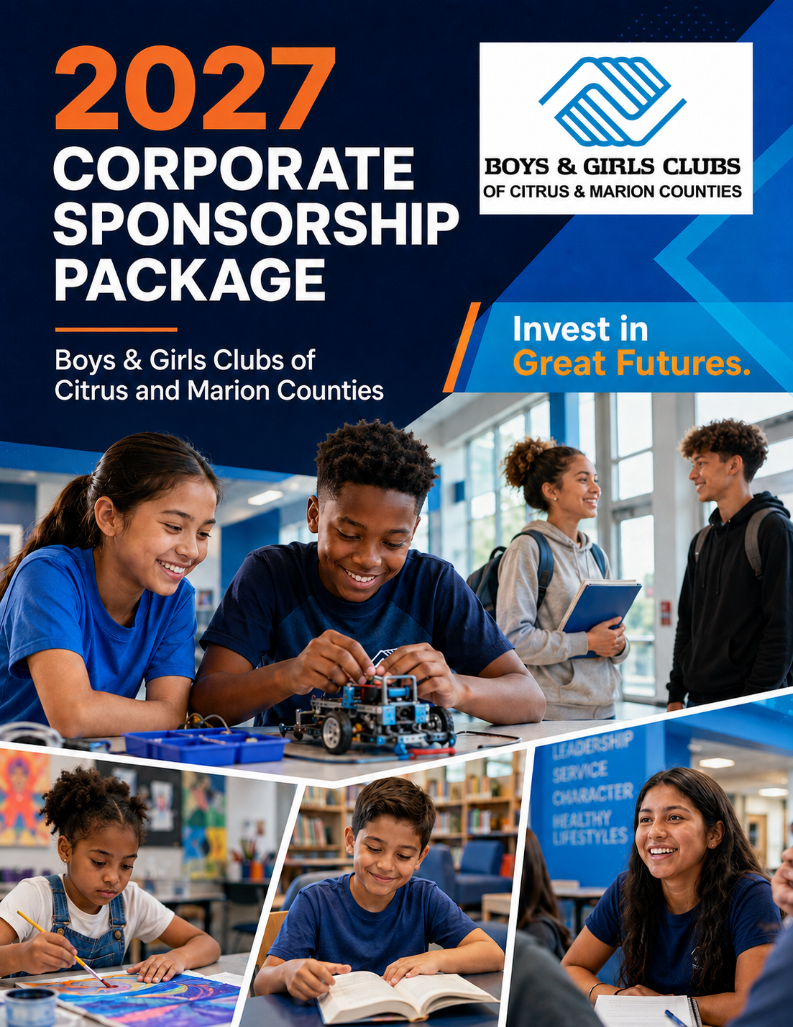
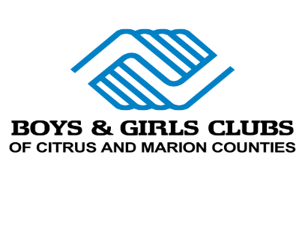 | 2027 CORPORATE BUSINESS SPONSOR PACKAGES

INVEST IN GREAT FUTURES
Corporate partnership opportunities for 2027
Your partnership helps young people across Citrus and Marion Counties reach their full potential.
LEGEND | $100,000
20 total tickets to event fundraisers
VIP experience at all events, including tickets and a personal concierge
Title Sponsor recognition at all events
Logo shout-outs on Facebook and Instagram four times annually
Recognition as a Corporate Business Partner at events
Event Facebook recognition and event promotion/giveaway sponsorship
Business logo on Summer T-shirts (500+)
Logo displayed in Club foyers
Four business-sponsored ice cream socials in our Clubs
Linked logo on the Boys & Girls Clubs website
Pizza party with Club members and the CEO
Logo recognition in the newsletter
Social media interview showcasing your business
Presenting sponsor for three Club events
Consideration for the Board of Directors
Recognition plaque in the Clubs
Naming consideration for future Clubs or areas of Clubs (restrictions apply)
Billboard highlighting the partnership
Logo or mention on all marketing materials

2027 CORPORATE BUSINESS SPONSOR PACKAGES

MONUMENTAL | $50,000
20 total tickets to event fundraisers
VIP experience at all events, including tickets and a personal concierge
Title Sponsor recognition at all events
Logo shout-outs on Facebook and Instagram four times annually
Recognition as a Corporate Business Partner at events
Event Facebook recognition
Business logo on Summer T-shirts (500+)
Logo displayed in Club foyers
Four business-sponsored ice cream socials in our Clubs
Linked logo on the Boys & Girls Clubs website
Pizza party with Club members and the CEO
Logo recognition in the newsletter
Social media interview showcasing your business
Presenting sponsor for three Club events
Event promotion/giveaway sponsorship
Consideration for the Board of Directors
Recognition plaque in the Clubs
Lifetime Board Member recognition
Naming consideration for a room or area of a Club (restrictions apply)

2027 CORPORATE BUSINESS SPONSOR PACKAGES

SPECTACULAR | $25,000
20 total tickets to event fundraisers
VIP experience at all events, including tickets and a personal concierge
Presenting Sponsor recognition at one Club event
Logo shout-outs on Facebook and Instagram four times annually
Recognition as a Corporate Business Partner at events
Event Facebook recognition
Business logo on Summer T-shirts (500+)
Logo displayed in Club foyers
Four business-sponsored ice cream socials in our Clubs
Linked logo on the Boys & Girls Clubs website
Pizza party with Club members and the CEO
Logo recognition in the newsletter
Social media interview showcasing your business
Presenting sponsor for three Club events
Event promotion/giveaway sponsorship
Consideration for the Board of Directors
Recognition plaque in the Clubs
Honorary Board Member recognition for one year

2027 CORPORATE BUSINESS SPONSOR PACKAGES

PLATINUM | $10,000
10 total tickets to event fundraisers
Logo shout-outs on Facebook and Instagram four times annually
Recognition as a Corporate Business Partner at events
Event Facebook recognition and event promotion/giveaway sponsorship
Business logo on Summer T-shirts (500+)
Logo displayed in Club foyers
Four business-sponsored ice cream socials in our Clubs
Linked logo on the Boys & Girls Clubs website
Pizza party with Club members and the CEO
Logo recognition and presented-by recognition in two newsletters
Social media interview showcasing your business
Presenting sponsor for three Club events

DIAMOND | $7,500
10 total tickets to event fundraisers
Logo shout-outs on Facebook and Instagram four times annually
Recognition as a Corporate Business Partner at events
Event Facebook recognition and event promotion/giveaway sponsorship
Business logo on Summer T-shirts (500+)
Logo displayed in Club foyers
Three business-sponsored ice cream socials in our Clubs
Linked logo on the Boys & Girls Clubs website
Pizza party with Club members and the CEO
Logo recognition and presented-by recognition in one newsletter
Social media interview showcasing your business
Sponsor recognition at one Club event

2027 CORPORATE BUSINESS SPONSOR PACKAGES

EMERALD | $5,000
10 total tickets to event fundraisers
Logo shout-outs on Facebook and Instagram two times annually
Recognition as a Corporate Business Partner at events
Event Facebook recognition
Business logo on Summer T-shirts (500+)
Two business-sponsored ice cream socials in our Clubs
Logo recognition and one-time presented-by recognition in the monthly newsletter
Linked logo on the Boys & Girls Clubs website
Pizza party with Club members and the CEO
Social media interview showcasing your business
Sponsor recognition at one Club event

RUBY | $2,500
4 total tickets to event fundraisers
Logo and shout-out on Facebook and Instagram
Recognition as a Corporate Business Partner at events
Event Facebook recognition
Business logo on Summer T-shirts (500+)
Logo displayed in Club foyers
Business-sponsored ice cream social in our Clubs
Logo recognition in the newsletter
Logo on the Boys & Girls Clubs website

SAPPHIRE | $1,200
Logo on the Boys & Girls Clubs website
4 total tickets to event fundraisers
Logo and shout-out on Facebook and Instagram
Recognition as a Corporate Business Partner at events
Event Facebook recognition
Business name on Summer T-shirts (500+)

2027 CORPORATE PARTNER COMMITMENT

BECOME A 2027 CORPORATE PARTNER
Thank you for investing in the next generation of leaders.
Sponsorship level ____________________________________________________________________
Pledge amount $____________________________________________________________________
PAYMENT OPTION ☐ Check enclosed ☐ Please invoice quarterly ☐ Credit card
CARD NUMBER  ______________________________ | EXPIRATION DATE  ______________________________
SECURITY CODE (CCV)  ______________________________ | BILLING ZIP CODE  ______________________________
AUTHORIZED SIGNATURE  ______________________________ | DATE  ______________________________

CONTACT INFORMATION
NAME  ____________________________ | TITLE  ____________________________
COMPANY  ____________________________ | PHONE  ____________________________
ADDRESS  ____________________________ | EMAIL  ____________________________
CITY, STATE, ZIP  ____________________________ | DATE  ____________________________
MAIL COMPLETED FORM AND PAYMENT TO
Boys & Girls Clubs of Citrus and Marion Counties • 255 SE 7th Avenue, Crystal River, FL 34429

For Questions, call our Corporate Office at (352) 621-9225

