

We are thrilled about the upcoming school year and express our gratitude for your interest in joining the Boys & Girls Clubs of Citrus County and our programs. I have a few very important things that I would like to go over with you so you understand our expectations about this upcoming year.

When filling out your application please make sure that it is filled out entirely. If information is missing, we can’t accept your application and place your child into our program. The following areas that seem to get left out on a great deal of our applications are the following.

- Citrus County Student ID# (this is a 7 digit # giving to students by Citrus County School board)
- FL 12# Student ID (this is given out by the state of Florida and is 12 digits long)
  - If you don’t know how to get your Childs Numbers you can call Student Services at 352-527-0090 and they will get you the information needed.
- Medical information is critical to the safety of our Members and your child. If your child has ANY allergies or medical conditions please let us know.
- Demographic information-this section is CRITICAL to our grant writing which allows us to do the fun things we can and also keeps the cost of Programs down.
The Boys & Girls Clubs of Citrus County closes at 6:30 pm every day. All Members MUST be picked up by 6:30 pm EVERYDAY. Habitual late pick up will result in your child being removed from the program. This will be STRICKLY enforced this year. We understand things happen and are sympathetic of this, but if late pick up is a constant your child will unfortunately be removed from the program.

If you participate in our Before School Program it will be $85 a month. Fees each month will be due on the 1st of the month. If you are set up on Auto Pay, your payment will be charged on the 1st of every month. If the 1st of the month is a weekend or a holiday, you will be charged the following business day. If you do not pay your monthly fees, your child will not be permitted to attend until all fees are paid. Financial assistance is available for those that need it, and you can get paperwork from your Club Director to fill out and provide the required documents.

Lastly, in order to participate in our Holiday Camp, Spring Break Camp, and No School Days you have to be registered for our Afterschool Program.

We know that this year is going to be the best year yet. If you have any questions please contact your Club Director or send us an email at info@bgccitrus.org.
Be Great,
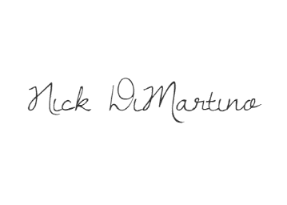
Nick DiMartino
Director of Operations



Boys & Girls Clubs of Citrus County Registration Packet

I would like for my child _______________________________ to participate in the following BGC programs.

_____ Before School only - Central Ridge Club, Chad Halleen Club, Evelyn Waters Club, Robert Halleen Club ($85 monthly with payment due on the 1st of each month)
_____ Before and After School - Central Ridge Club, Evelyn Waters Club, Robert Halleen Club ($85 Monthly with payment due on the 1st of each month)
_____ Before and After School - Chad Halleen Club ($210 Monthly with payment due on the 1st of each month)
_____ After School Only - Central Ridge Club, Evelyn Waters Club, Robert Halleen Club ($0 monthly fee for After School only)
_____ After School Only - Chad Halleen Club ($125 monthly fee for After School only)
_____ Please enroll my child in the BGC Auto Draft Payment Program (If the 1st of the month falls on a weekend or a holiday, my card will be charged on the next business day)

- Monthly fees are subject to change based on availability of 21st Century funding.

I ______________________________ agree to pay my monthly Before School fee by the 1st of each month and understand that failure to do so may result in my child from being removed from the Before School program.

BOYS & GIRLS CLUBS OF CITRUS COUNTY RULES
- Stay in assigned area
- Respect staff & other members at all times
- Keep hands & feet to yourself
- Walk inside of the building

Consequences for Actions………
- 1st Referral……………Warning
- 2nd Referral…………...Warning
- 3rd Referral……………One Day Suspension
- 4th Referral……………Two Day Suspension and Parent Conference
- 5th Referral……………Withdrawal from Program

Members MUST NOT…….

- Fight or intentionally inflict physical harm on other club members or staff
- Vandalize or steal property from the club or its members
- Use inappropriate language or obscene gestures

Consequences for Actions……

- 1st Offense………….One Day Suspension
- 2nd Offense…………Two Day Suspension
- 3rd Offense…………Three Day Suspension
- 4th Offense…………Withdrawal from program

If a referral is written while on a field trip, it will be up to the Director’s discretion to suspend the child from the next field trip. Some circumstances may warrant immediate parent pickup.

We have read, discussed and understand the above rules, consequences & Code of Conduct listed above.

Members name: _______________________ Members signature: __________________

Parent/Guardian Signature: _________________________________________

Date Signed: ____________________

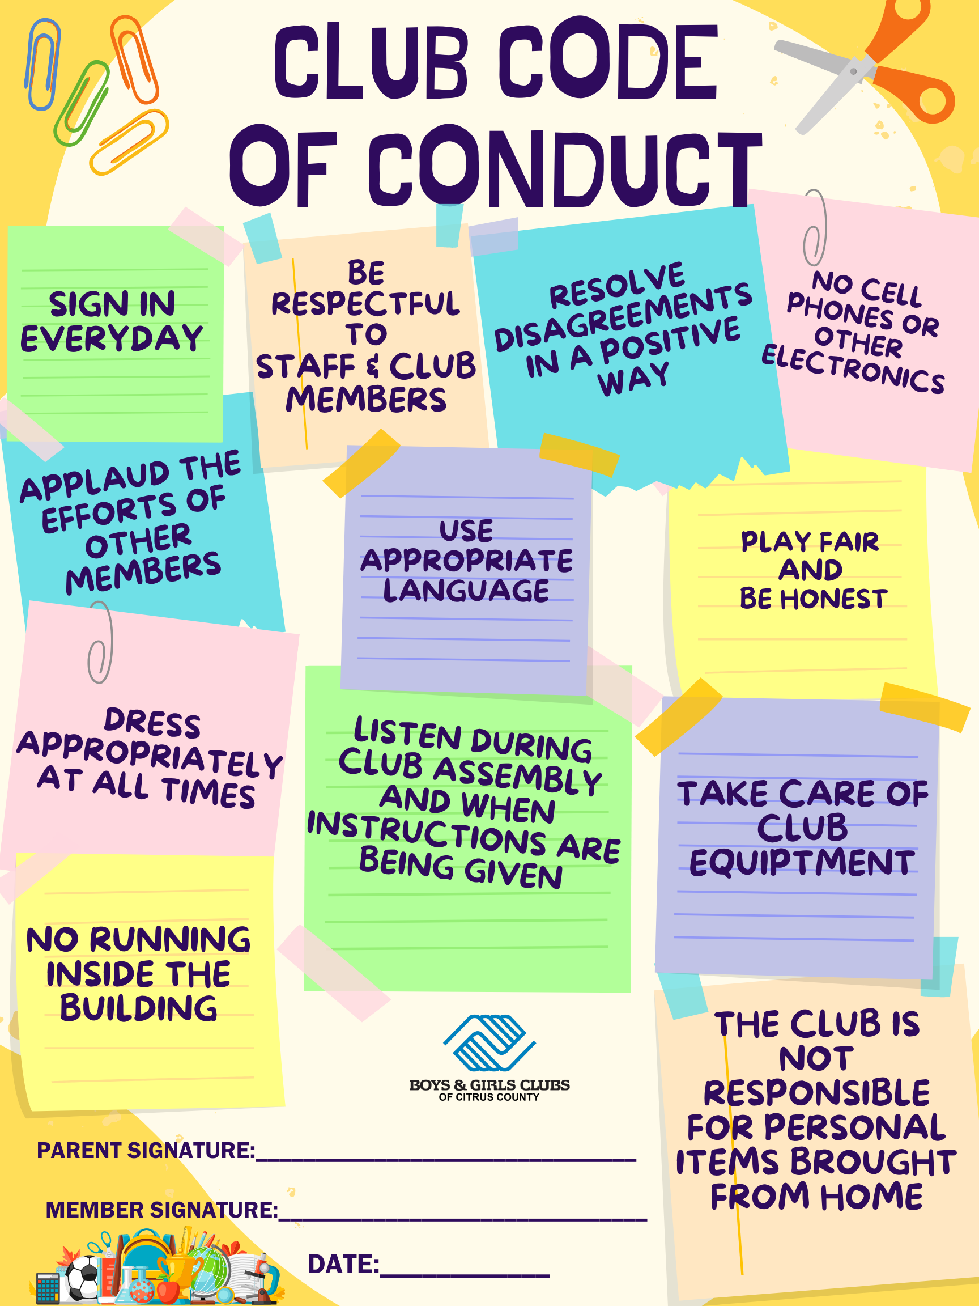

2025/2026 MEMBERSHIP APPLICATION



Unit Name: _____ Central Ridge (Beverly Hills) _____ Chad Halleen (Crystal River)
_____ Evelyn Waters (Inverness) _____ Robert Halleen (Homosassa)

First Name: ____________________ Middle: ________________ Last:__________________________________
Citrus County Student ID# ____________ FL12# Student ID_____________________ Nickname:____________
Gender: ___M ___F Ethnicity: __________________ DOB: ____________ Age: ____________
Address: ___________________________________________________________________
City: ______________________ State: _________ Zip: ________________ County: ___________________
Phone: ___________________ Email: ______________________________________________________
School Information: Are you enrolled in: ___ Free Lunch
Current Teacher: _________________________________ ___ Reduced Lunch
School: _____________________________________ Grade: _____ ___ Not Eligible
Medical Information:
Doctor Name: _____________________________ Doctor Phone: _________________________
Physical Challenges: ________________________ Disabilities: ________________________
Allergies (include allergy to any medication): _____________________________________________
Special Needs/Health Issues: ___Yes ___No If Yes, explain: ________________________________________
Medications: ___Yes ___No; If Yes, explain: _____________________________________________________
Additional Medical Information: ____________________________________________________________________

_______________________________________________________________________________________________

_________________________________________________________________________________________________
Physical Characteristics:
Eye Color: _____________ Hair Color: _______________ Skin Color/Features: ____________________
Height: ___________ Weight: ______________

FOR OFFICE USE ONLY: Membership #: ________ Student ID # __________
Entry Date: ______________ Expiration Date: ____________________ Status: _________________
Type: ________________ New/Renewal Member: _________________ Processed by: ____________

Household: NOTE: This demographic information is collected for Grant writing purposes ONLY

Member lives with: ____Mom ____Step Mom ____Dad ____Step Dad ____Grandparent
____Foster parent(s) ____Other: _____________
Annual $0 - $5000 _____ $30,001 - $35,000 _____ $60,001 - $65,000 _____
Income $5001 - $10,000 _____ $35,001 - $40,000 _____ $65,001 - $70,000 _____
Level: $10,001 - $15,000 _____ $40,001 - $45,000 _____ $70,001 - $75,000 _____
$15,001 - $20,000 _____ $45,001 - $50,000 _____ $75,001 - $80,000 _____
$20,001 - $25,000 _____ $50,001 - $55,000 _____ $80,001 - $85,000 _____
$25,001 - $30,000 _____ $55,001 - $60,000 _____ $85,001 - $90,000+ _____
Is there a Member of the Household 65 years old or older: ____Yes ____No
Current Head of Household: ____Female ____Male ____Both Military Branch: ________________
Total Number in Household: _________________ Number in Household under 18: _________________
Is there a Member of the Household Handicapped: ____Yes ____No
Current Single Parent: ____Yes ____No Lives on Military Base: ____Yes ____No
TERMS & CONDITIONS
PLEASE INITIAL THAT YOU HAVE READ EACH PARAGRAGH….
____ PARENT HANDBOOK I have received a copy of the Boys & Girls Clubs of Citrus County handbook and agree to the Terms & Conditions on Page 13 of the Parent Handbook.
____CLUB RULES & CODE OF CONDUCT I agree to review the Clubs rules and consequences along with the Code of Conduct with my children. I understand that membership can be suspended or revoked should behavior warrant such action.
____Report Cards and Student Grades I agree to provide my child’s grades each nine weeks as part of membership to the Boys & Girls Clubs of
Citrus County. I understand that my child’s membership may be suspended or discharged in the event my child/children does not submit Report
Cards within one week of request.
____PICTURE RELEASE I release the right to all photographic material that the Boys & Girls Club might use for promotional activities without Obligations to me or my child/children.
____RELEASE OF INFORMATION I understand that this program is funded through multi-funding agencies. I understand that generic information For all those served must be shared with these funders due to grant requirements and that this data will only be used for program monitoring, Funding, coordination and planning purposes.
____MOVIE RELEASE I give my child/children permission to watch PG movies in the event of rain, early release days or as optional activity.

It is expressly understood and agreed that the Boys & Girls Clubs of Citrus County is not liable for the loss of property or injury.
I understand that I am responsible for any damages that my child/children’s actions may incur and that membership could be suspended until restitution is made.
I give my permission for the Club’s staff or representative to administer first aid in the event that my child/children may require medical attention.
I hereby authorize the Boys & Girls Clubs of Citrus County, Inc. to secure such treatment, if neither parent/guardian is available to grant permission.
The parent/guardian hereby acknowledges and fully recognizes that this document does not constitute a contract and that the sole and exclusive remedy is withdrawal of the student from the program. The parent/guardian voluntarily and knowingly releases and agrees to save Boys & Girls Clubs of Citrus County Inc. harmless from all liability, in contract tort or otherwise, for any and all injuries arising out of actions by other students, other individuals, or employees of Boys & Girls Clubs except for certain tortuous acts of the Boys & Girls Clubs agents, officers, and employees to the extent and limit provided by Section 768.28, Florida Statutes, the State of Florida’s partial waiver of sovereign immunity. This provision is not to be construed as a waiver of any right of defense that the Board may possess.

I fully understand and agree to all terms and conditions stated on this form.
Parent/Guardian Signature: _______________________________________ Date: _____________________

MEMBERS CONTACT AND PICKUP LIST

Member’s Name: _____________________________________

PRIMARY CONTACT 1  Name: _________________________________  Parent/Guardian: ____ Emergency: ____  Person Authorized to Pick up Member: ____  Relationship to Member: _______________________  Phone: ____________________ Type: _____________  Phone: ____________________ Type: _____________  Employer: _____________________________ | PRIMARY CONTACT 2  Name: _________________________________  Parent/Guardian: ____ Emergency: ____  Person Authorized to Pick up Member: ____  Relationship to Member: _______________________  Phone: ____________________ Type: _____________  Phone: ____________________ Type: _____________  Employer: _____________________________
Name: _________________________________  Parent/Guardian: ____ Emergency: ____  Person Authorized to Pick up Member: ____  Relationship to Member: _______________________  Phone: ____________________ Type: _____________  Phone: ____________________ Type: _____________ | Name: _________________________________  Parent/Guardian: ____ Emergency: ____  Person Authorized to Pick up Member: ____  Relationship to Member: _______________________  Phone: ____________________ Type: _____________  Phone: ____________________ Type: _____________
Name: _________________________________  Parent/Guardian: ____ Emergency: ____  Person Authorized to Pick up Member: ____  Relationship to Member: _______________________  Phone: ____________________ Type: _____________  Phone: ____________________ Type: _____________ | Name: _________________________________  Parent/Guardian: ____ Emergency: ____  Person Authorized to Pick up Member: ____  Relationship to Member: _______________________  Phone: ____________________ Type: _____________  Phone: ____________________ Type: _____________

Citrus County School District
PARENT/GUARDIAN/ADULT
PERMISSION FOR RELEASE OF STUDENT RECORDS


Name of School: ______________________________________________Date: ______________

Address: ______________________________________________________________________
Street/PO Box City State Zip

Note: If records have been transferred, please forward request to the institution/agency/office holding this student's records.
I hereby give permission to release the following information from the educational records of:

Student's Name Last First Ml

Address: Street/PO Box City State Zip

Grade: Date of Birth: Student Number: ____________________
/

FL 12# Student Number______________________

Please release the following:
X Achievement Test Scores Most recent IEP
X Grades (to time of withdrawal/current year

The records indicated above are to be released to;
Name of Institution/Agency/Individual: Boys & Girls Clubs of Citrus County.

Address: PO Box 907 Lecanto FL 34460 Street/PO Box City State Zip
ATTENTION:

I authorize the release of the above information to the institution and/or the individual named. I understand that I have a right to review all records being forwarded, prior to their release. I have also been informed that I have a right to a hearing to contest any information Contained in these records prior to their release.

Date Signature of Parent/Guardian/Adult Student



Authorization for Credit Card Transaction

I ______________________________________ authorize the Boys & Girls Clubs of Citrus County to keep my credit card information on file to autopay my monthly fees. I understand that my card will be charged on the due date for each month (1st business day of the month). This will continue until I ask the Boys & Girls Clubs of Citrus County to stop using the automatic payment method in writing.

__________________________________ ___________
Signature Date

Member’s Name ___________________________________________

Card # _____________________________________
Card Holder Name _________________________________________________
Expiration Date _______________________
3 Digit Code _________
Card Holder Billing Address ___________________________________________
___________________________________________________________________

