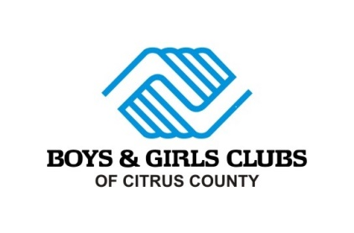

Corporate Business Sponsor Packages
Legend - $100,000

- VIP experience at all of our events
  - Tickets
  - Limo service
  - Personal Concierge
- Title Sponsor at all events
- Logo shout out on Facebook, Instagram, and Twitter 4 times annually
- Recognition as Corporate Business Partner at our events
- Event Facebook recognition/ Event promo/giveaway sponsor
- Your business logo on our Summer T-Shirts (500+)
- Logo in our club foyers
- Ice Cream Social sponsored by your business in our clubs (x4)
- Your logo w/ website link on Boys & Girls Clubs’ website
- Pizza Party with Boys & Girls Clubs of Citrus County Club kids and CEO
- Logo in our club foyers
- Logo recognition in our monthly newsletter
- Your business will be the monthly newsletter presented by sponsor (x4)
- Social media interview/showcasing your business
- Presenting sponsor for club events (x3)
- Transportation sponsor with logo on our bus
- Board of Directors Consideration
- Plaque in the Clubs
- Lifetime Board Member
- Name consideration for future Clubs or areas of Clubs (restrictions apply)
- Billboard with partnership with BGC highlighted
- Logo or mention on all marketing materials
Monumental - $50,000

- VIP experience at all of our events
  - Tickets
  - Limo service
  - Personal Concierge
- Title Sponsor at all events
- Logo shout out on Facebook, Instagram, and Twitter 4 times annually
- Recognition as Corporate Business Partner at our events
- Event Facebook recognition
- Your business logo on our Summer T-Shirts (500+)
- Logo in our club foyers
- Ice Cream Social sponsored by your business in our clubs (x4)
- Your logo w/ website link on Boys & Girls Clubs’ website
- Pizza Party with Boys & Girls Clubs of Citrus County Club kids and CEO
- Logo in our club foyers
- Logo recognition in our monthly newsletter
- Your business will be the monthly newsletter presented by sponsor (x2)
- Social media interview/showcasing your business
- Presenting sponsor for club events (x3)
- Transportation sponsor with logo on our bus
- Event promo/giveaway sponsor
- Board of Directors Consideration
- Plaque in the Clubs
- Lifetime Board Member
- Name consideration for a room or area of a Club (Restrictions Apply)

Spectacular - $25,000
- VIP experience at all of our events
  - Tickets
  - Limo service
  - Personal Concierge
- Logo shout out on Facebook, Instagram, and Twitter 4 times annually
- Recognition as Corporate Business Partner at our events
- Event Facebook recognition
- Your business logo on our Summer T-Shirts (500+)
- Logo in our club foyers
- Ice Cream Social sponsored by your business in our clubs (x4)
- Your logo w/ website link on Boys & Girls Clubs’ website
- Pizza Party with Boys & Girls Clubs of Citrus County Club kids and CEO
- Logo in our club foyers
- Logo recognition in our monthly newsletter
- Your business will be the monthly newsletter presented by sponsor (x2)
- Social media interview/showcasing your business
- Presenting sponsor for club events (x3)
- Transportation sponsor with logo on our bus
- Event promo/giveaway sponsor
- Board of Directors Consideration
- Plaque in the Clubs
- Honorary Board Member for 1 year

Platinum - $10,000
- 40 total tickets to event fundraisers
- Logo shout out on Facebook, Instagram, and Twitter 4 times annually
- Recognition as Corporate Business Partner at our events
- Event Facebook recognition- Event promo/giveaway sponsor
- Your business logo on our Summer T-Shirts (500+)
- Logo in our club foyers
- Ice Cream Social sponsored by your business in our clubs (x4)
- Your logo w/ website link on Boys & Girls Clubs’ website
- Pizza Party with Boys & Girls Clubs of Citrus County Club kids and CEO
- Logo recognition in our monthly newsletter/ 2 monthly presenter of newsletter
- Social media interview/showcasing your business
- Presenting sponsor for club events (x3)
- Transportation sponsor with logo on our bus
- Limo transportation provided for 1 event (Steak & Steak or Suitcase Party)
Diamond- $7,500

- 30 total tickets to event fundraisers
- Logo shout out on Facebook, Instagram, and Twitter 4 times annually
- Recognition as Corporate Business Partner at our events
- Event Facebook recognition- Event promo/giveaway sponsor
- Your business logo on our Summer T-Shirts (500+)
- Logo in our club foyers
- Ice Cream Social sponsored by your business in our clubs (x3)
- Your logo w/ website link on Boys & Girls Clubs’ website
- Pizza Party with Boys & Girls Clubs of Citrus County Club kids and CEO
- Logo recognition in our monthly newsletter/ 1 monthly presenter of newsletter
- Social media interview/showcasing your business
- Event sponsor for one club event
- Transportation sponsor with logo on our bus

Emerald - $5,000
- 20 total tickets to event fundraisers
- Logo shout out on Facebook, Instagram, and Twitter 2 times annually
- Recognition as Corporate Business Partner at our events
- Event Facebook recognition
- Your business logo on our Summer T-Shirts (500+)
- Logo in our club foyers
- Ice Cream Social sponsored by your business in our clubs (x2)
- Logo recognition in our monthly newsletter and one-time monthly sponsor
- Your logo w/ website link on Boys & Girls Clubs’ website
- Pizza Party with Boys & Girls Clubs of Citrus County Club kids and CEO
- Social media interview/showcasing your business
- Event sponsor for one club event
Ruby - $2,500
- 15 total tickets to event fundraisers
- Logo and shout out on Facebook, Instagram, and Twitter
- Recognition as Corporate Business Partner at our events
- Event Facebook recognition
- Your business logo on our Summer T-Shirts (500+)
- Logo in our club foyers
- Ice Cream Social sponsored by your business in our clubs
- Logo recognition in our monthly newsletter
- Logo on Boys & Girls Clubs’ website
Sapphire - $1,200
- 10 total tickets to event fundraisers
- Logo and shout out on Facebook, Instagram, and Twitter
- Recognition as Corporate Business Partner at our events
- Event Facebook recognition
- Your business name on our Summer T-Shirts (500+)
- Logo in our club foyer

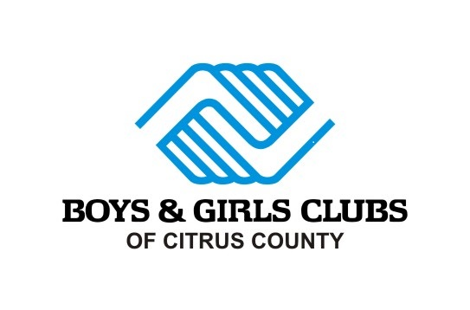

Yes, I would like to become a 2023 __________________Level Corporate Business Partner

I pledge/donate $________________ for 2022 to Boys & Girls Clubs of Citrus County

___ My check is enclosed for the full amount
___ Please bill me on a quarterly basis

Please Charge my: ___ MasterCard ___Visa

Card #: Exp. Date:_________
3 digit CCV:

Zip Code related to card:__________Signature:___________________________

Name: Date

Company: Title: _____

Address _____

City State Zip Phone

Donate through Mail: 2021 S. Suncoast Blvd. Homosassa Fl. 34448

